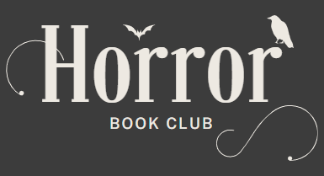
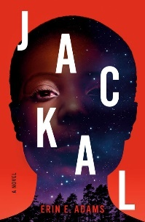

Jackal by Erin E. Adams
Meeting date: Thursday, June 6th, 2024
Time: 7 p.m.

Discussion Questions
- Liz’s mother, Marie, holds both herself and Liz to incredibly high standards. And as Liz says, “this made her an excellent doctor, but a hard person to live with. Everyone in front of her is a patient that needs to be fixed.” In what ways did Marie’s perfectionism hurt Liz growing up? In what ways did it help her?
- While she knows it’s fueled by love, a part of Liz resents her mother’s constant judgment. And now that she’s returned home as an adult, there’s a completely new dynamic between them. How do you think their relationship changed? How has it stayed the same?
- Throughout Jackal, Adams highlights the disparity in action and attention when Black women go missing in America. The town’s apathy after each girl’s disappearance directly contributes to their deaths; arguably as much as the killers themselves. What parallels are there between the white residents’ passivity in the novel and white Americans’ passivity in the real world? How does this fit into a larger conversation about racism here?
- Adams spotlights two tragic events in Johnstown, the widely publicized Johnstown Flood of 1889 and the lesser-known Great Banishment of 1923. Amidst the racial tension of the early-20th century, when Black communities were being uprooted and/or destroyed during the East St. Louis Riots of 1917 and the Tulsa Massacre of 1921, how do you think the disastrous flood might have laid the groundwork for racial division in Johnstown? Did you already know the history of these cities? If not, has this changed your perspective? We’ve included additional information of these historical events in your book club kit.
- Dreams play a key role in this book, and are written as poetry, not prose. How do you think that changed your reading experience? Which dreams stuck out to you most? Why?
- From Melissa’s father, to Nick, there are a lot of potential suspects in the story. Who was your first suspect? Who was your last? Why?
- It’s not just people who are suspects in this book, though. When did you first start to think something supernatural might be involved? What was your first theory?
- Keisha believed that there was only space for one successful Black person in her school. Right before her death, she has a change of heart when she sees Liz in the woods. Where do you think her way of thinking originated? How would their lives have been different if Liz and Keisha had a chance to be friends?
- The Jackal says he learns something from each heart of the missing girls. Keisha taught the Jackal a heart can change. Morgan’s heart taught him the monstrosity in beauty. Kayla’s heart taught the Jackal they needed a partner worth being brave for. Brittany’s heart taught him about hunger. When Jack pours all these gifts into Liz, she denies them. What do you believe is the meaning behind each gift? Would you have been able to deny Jack?
- “I denied my pain. I cut away parts of myself. I made space for someone—something else. In pursuit of those words, I turned myself into the perfect vessel for a monster. I’m Black, but not like those Black people. I’m a woman, but not like other women. I’ve fractured myself as goodness demanded of me.” Liz has the realization that Jack wants to bend her to his image, the same way she has made herself smaller her whole life. Have you ever had to conform to societal expectations in order to succeed in this world? Have you ever lost yourself in the process? Do you relate to Liz’s words?

